**Experiment No. 2.1**

**Student Name:** Gaurav Kumar **UID:** 22MCC20177

**Branch:** MCA**–**CCD **Section/Group:** MCD-1/A

**Semester:** III **Date of Performance:** 15th Oct 23

**Subject Name:** CONTAINERIZATION **Subject Code:** 22CAH-742

WITH DOCKER

1. **Aim/Overview of the practical:**
   1. Deploy webapp with the help of Docker.
2. **Code for practical: (a)**

**Creating a container through CLI**

1. First open your **“Docker Desktop”**.

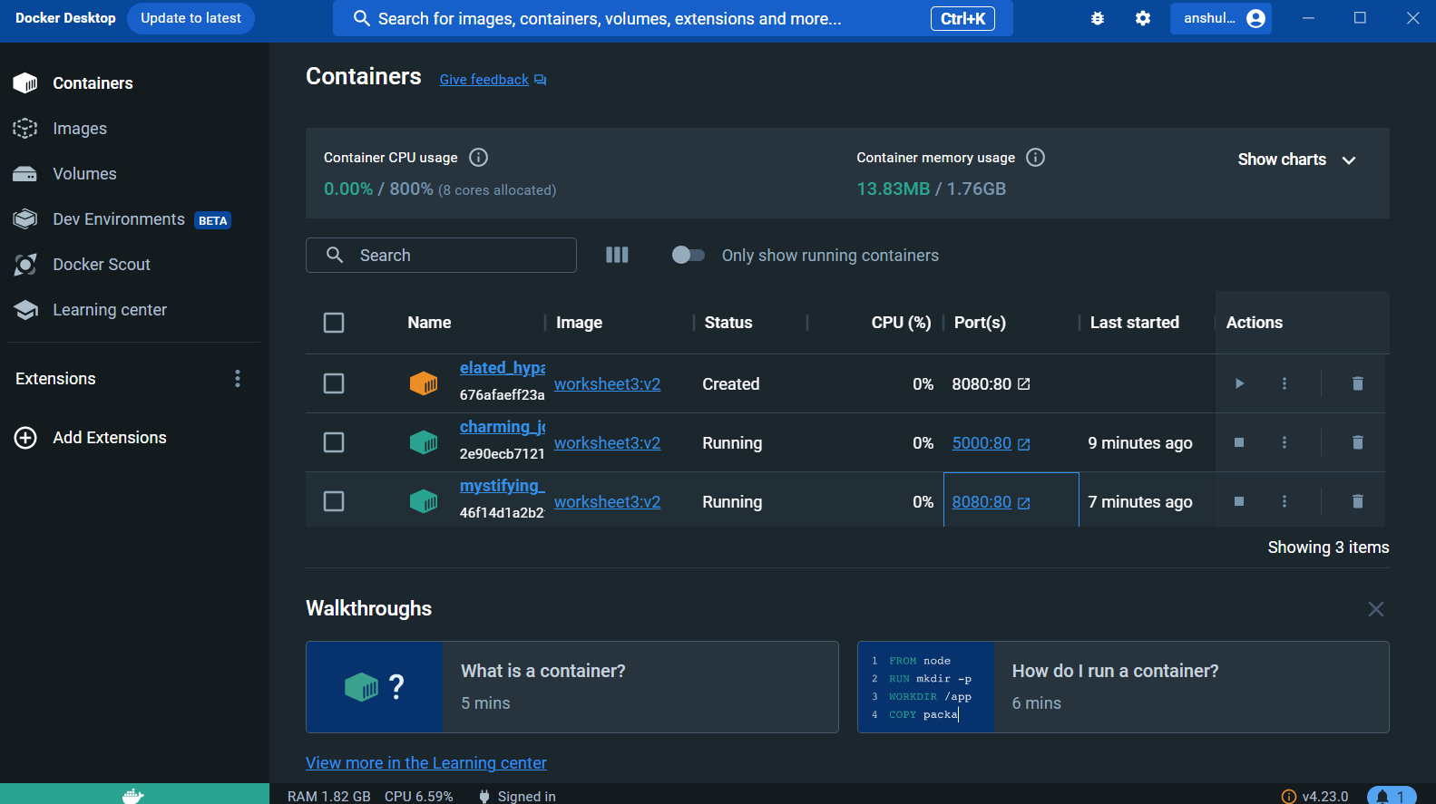

1. Open your Vs-code on your machine.
2. Create one folder inside that folder create two file one **“index.html”** another **“Dockerfile”**.

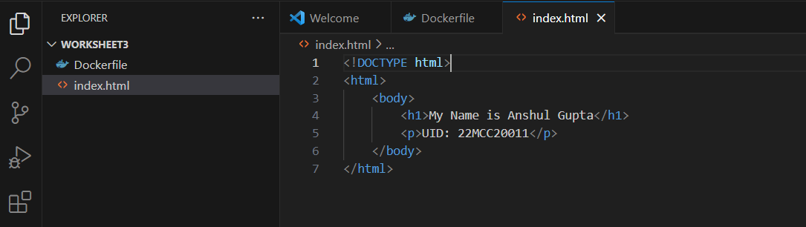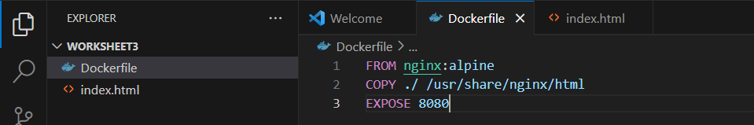

1. Use command **“docker build -t worksheet3:v2 .”** to build an image.

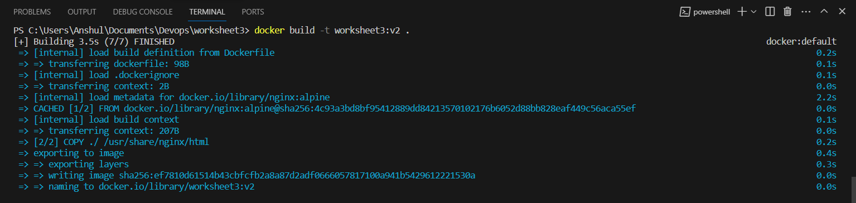

1. Now use command **“docker run -d -p 8080:80 worksheet3:v2”** to run the image.
2. Open browser and go to the port on which the application is running.

